**README FILE**

**Student Management System**

**Introduction**

One of the foundations of the knowledge, skills and education of the students came from the school and universities in which they hone their knowledge and profession and also to learn and rely upon. In that case schools and universities should maintain a proper storing of databases of students to maintain and update properly the records and files of the students in an easy and manageable way.

The online admission and student enrolment process in the school and universities are quite hard and tedious in terms of managing, analysing, planning, marketing, creating and handling all students’ records. To help the schools and universities in organizing and simply automate the record process by managing records through the student management system, through this tool it will be able to help the school and universities to enhance their performance efficiently and effectively. It can easily create a record, store, and update different records of the students.

Having a system that allows updating the students profile can enhance the workflow of the schools and can remain in constant contact and communication with all students, this will provide a less time cost for the teachers to do it manually and it can provide a much safer way to store files.

**Objectives of the Study**

1. To manage different students information
2. To easily update the records of the students' information.
3. To reduce the unnecessary paperwork in maintaining students information’s

**Student Management System Prototypes**

**Figure 1. Log in**

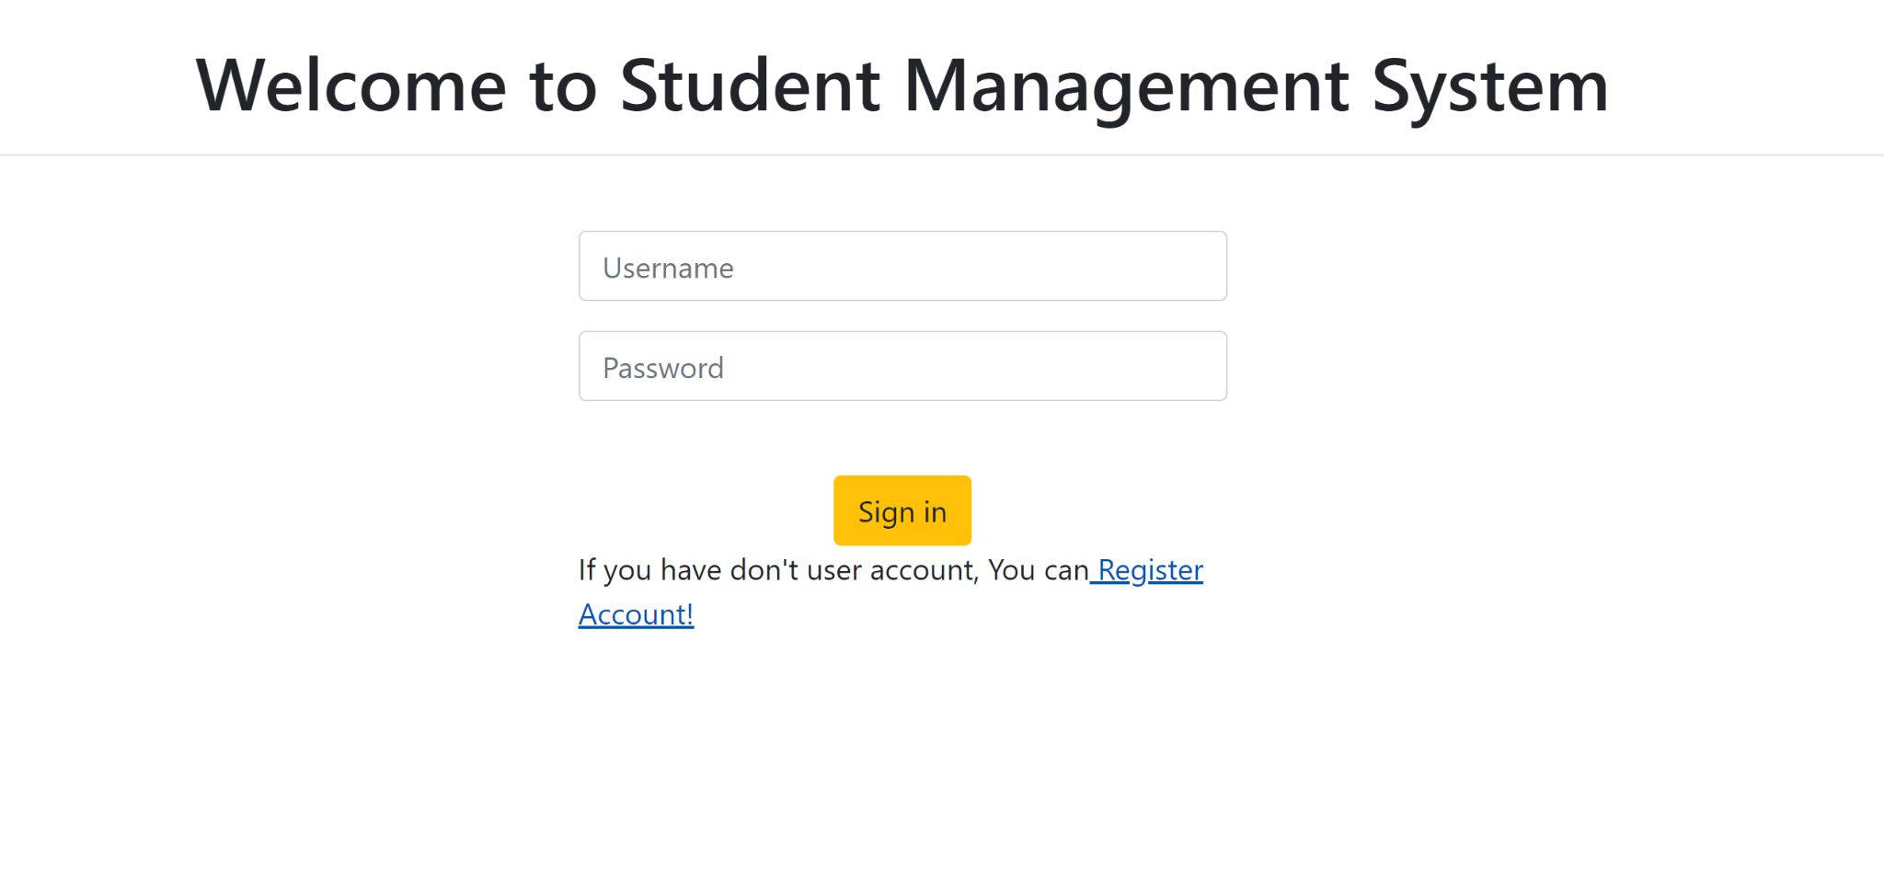

The user of the system should input their username together with their password then click the “login” button to proceed to the homepage of the system.

**Figure 2. Homepage**

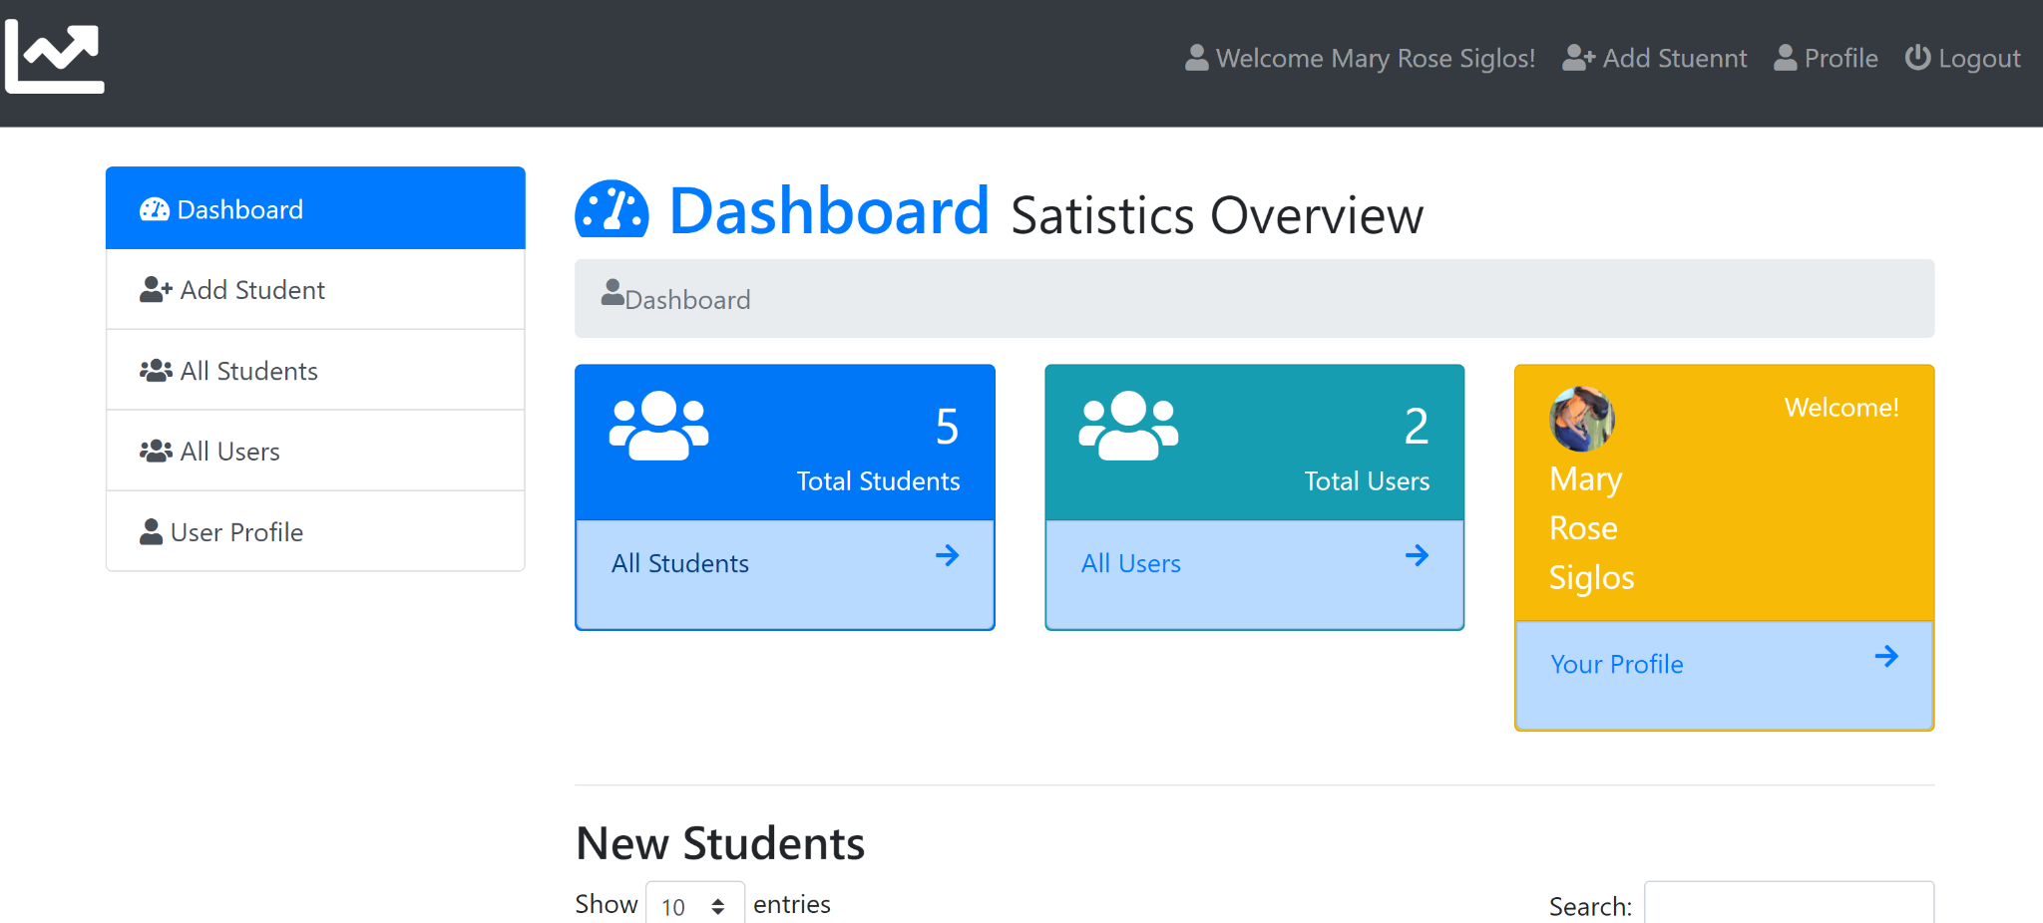

When you click the “login” button it will directly proceed to the homepage of the system. In the dashboard, it will display the total of the students, the total of users and the sign in account used. Once you click the “all students” this will display all students that have already added to the system. Then once you click the “all users” this will also display the all users or the person who has the access to perform the editing and updating of information of the students. On the left side of the screen are the different features of the system where users can add students, view all students, view all users and the user profile of the user.

**Figure 3. Adding of Student**

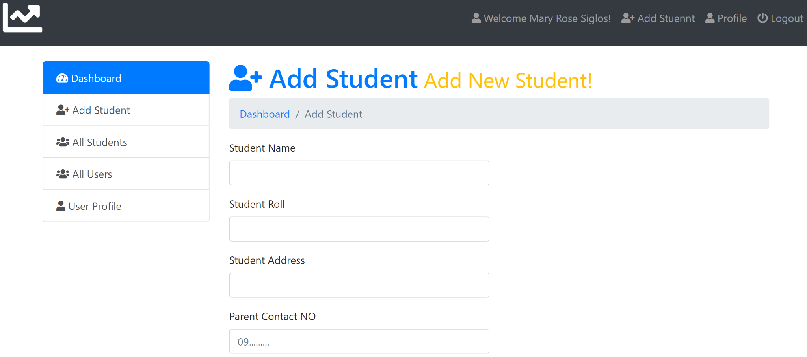

To add another student click the “add user” button on the left side and it will provide a form in which the user will fill up all the necessary information about the student.

**Figure 4. View all the list of Users**

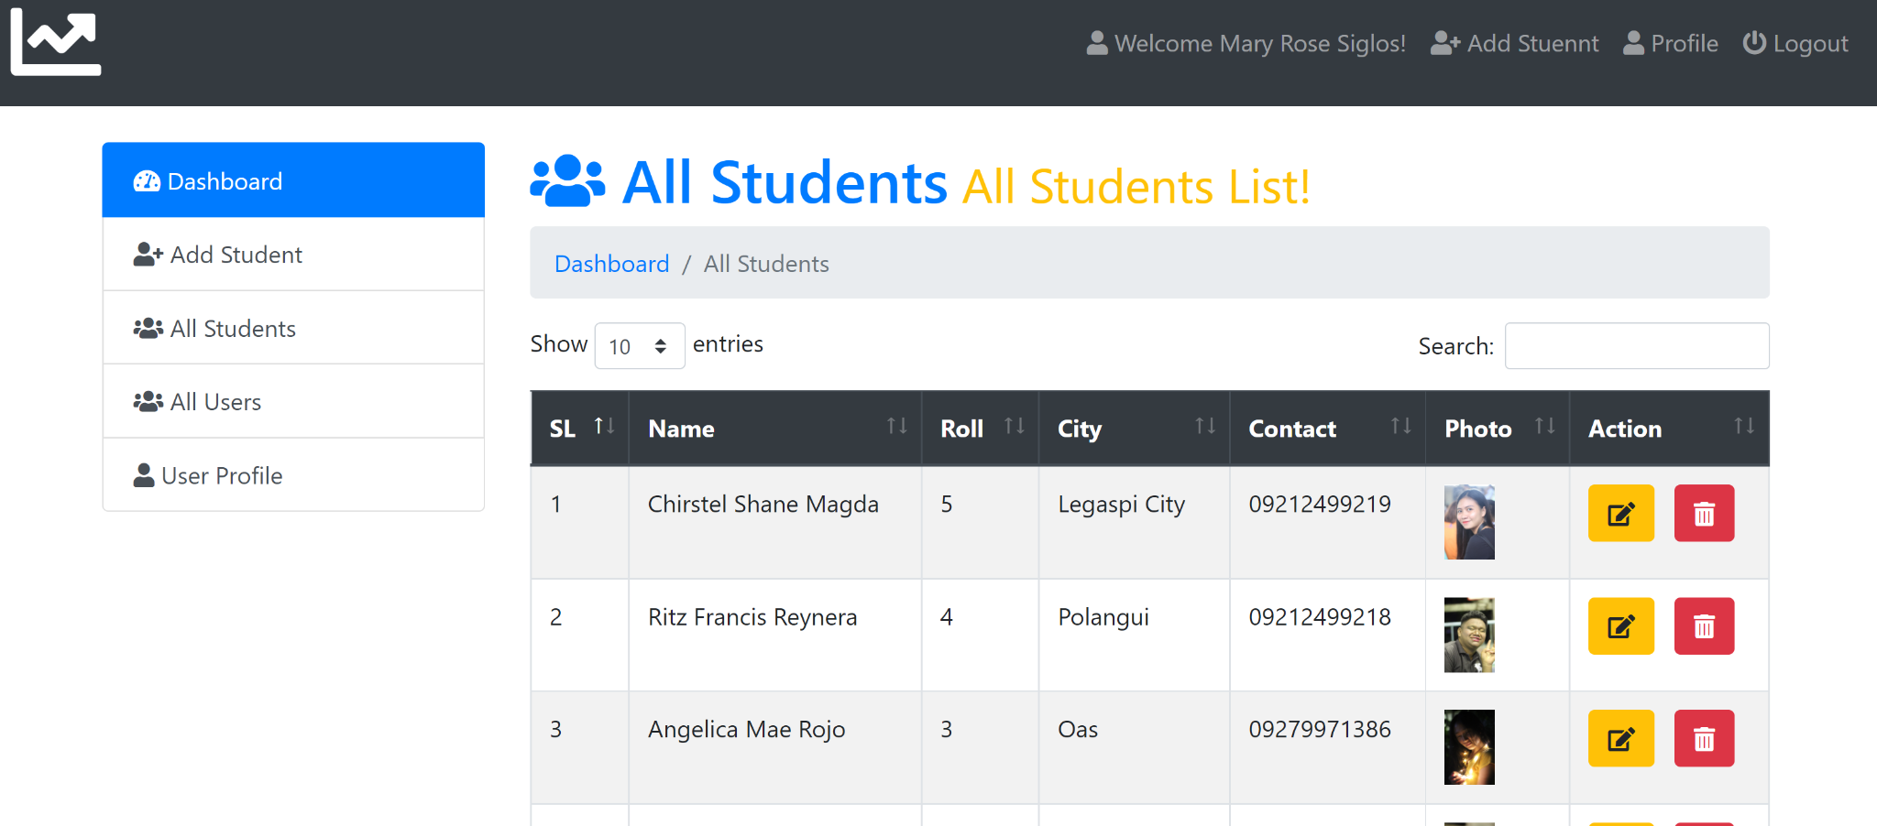

To view all the users list just click the “View all User” and this will show the total list and the users who currently have an access to the system about editing and updating students records.

**Figure 5. Editing of Records**

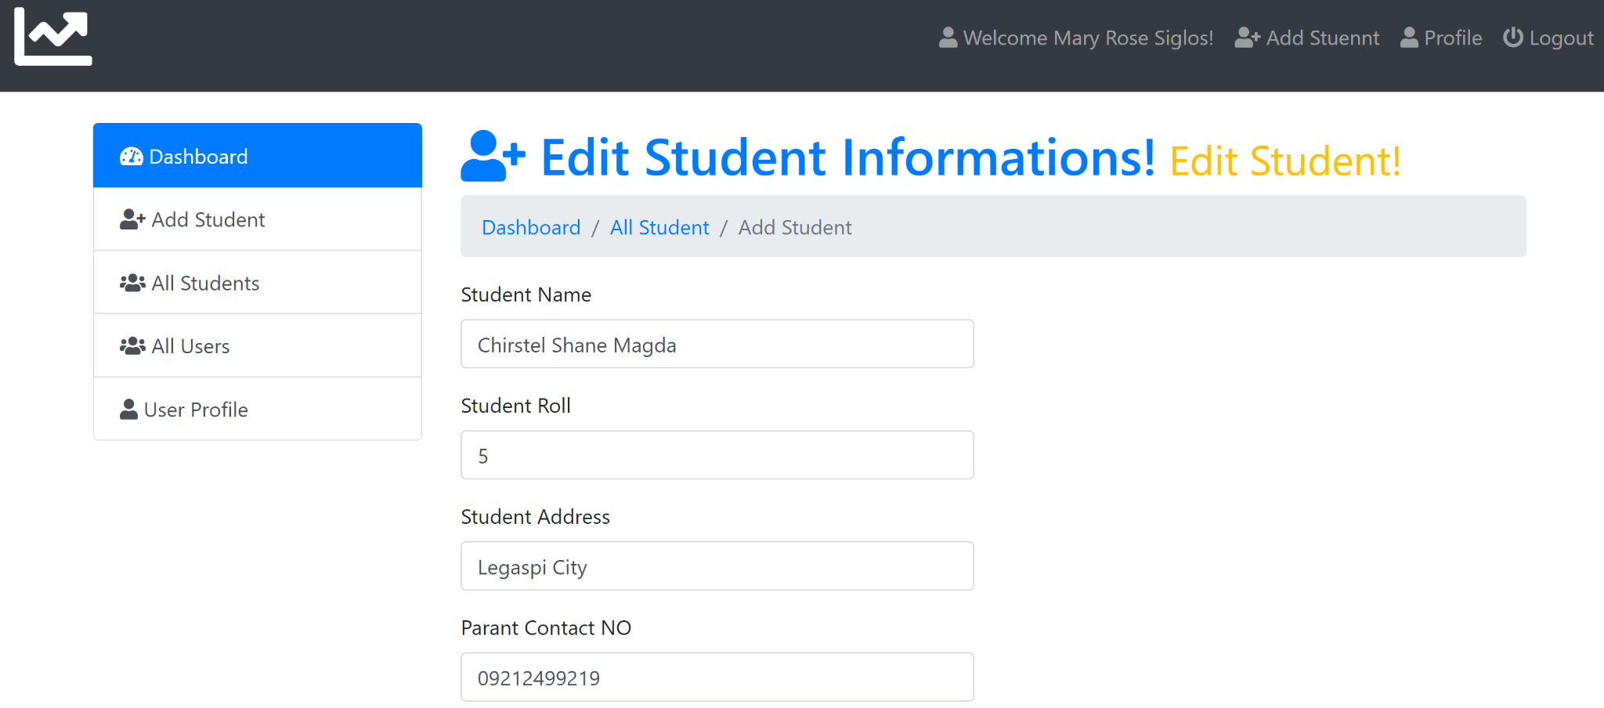

The admin of the system is the one who is capable of updating and editing the student’s records. If the admin wants to edit some information to the students, click the view all students then after that click the student profile or the student,then click the “edit” button in the right of the system and after that the information provided in the list will show then student profile on the list of all students

**Figure 6. User Profile**

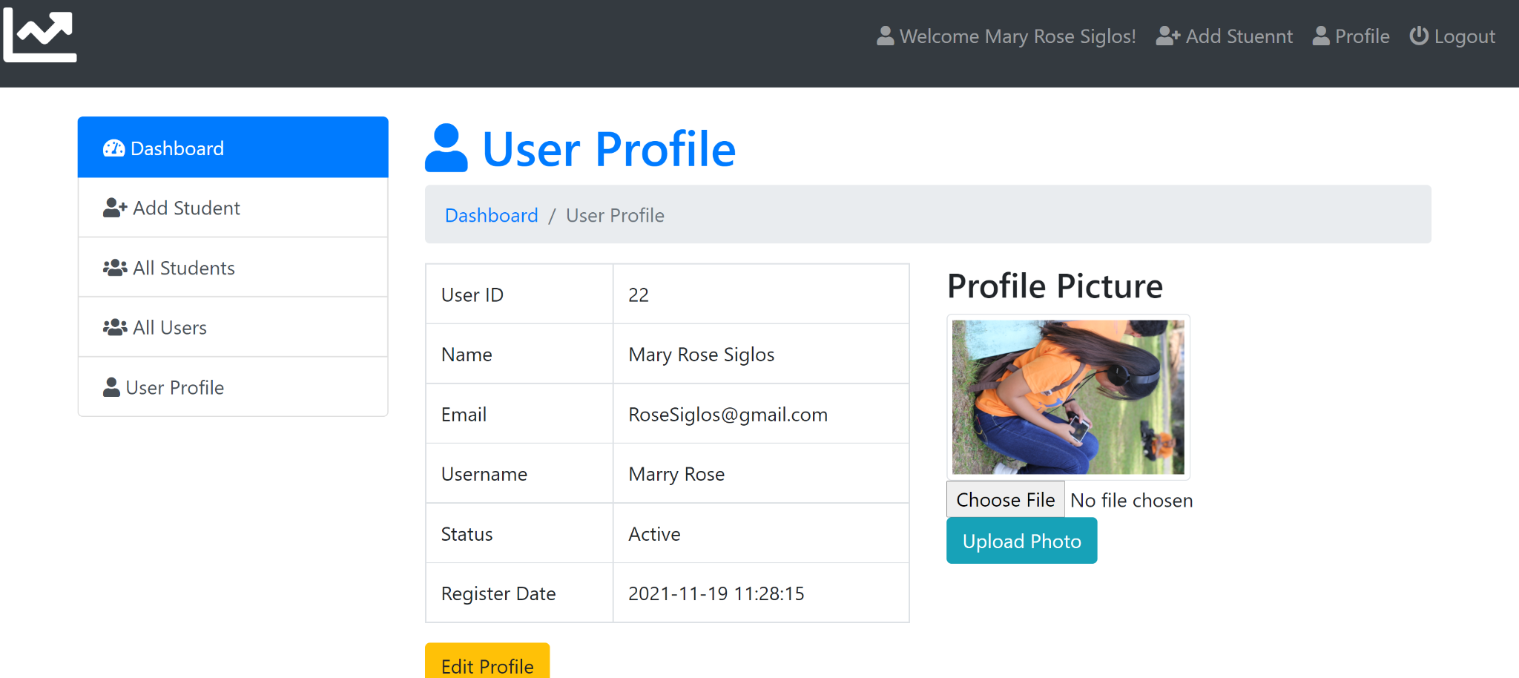

In the user profile section, when you click “User Profile”, it displays the information of the user who is using the system. This will show information that refers to the user. In order to view all the users who has an access to the system just click the “View all Users” on left side of the scree and after that it will display all users who are currently log in to the system